WE’VE GOT EACH OTHER
THE ALMOST ENTIRELY IMAGINED BON JOVI MUSICAL
by PAUL O’DONNELL
PRODUCTION PACK

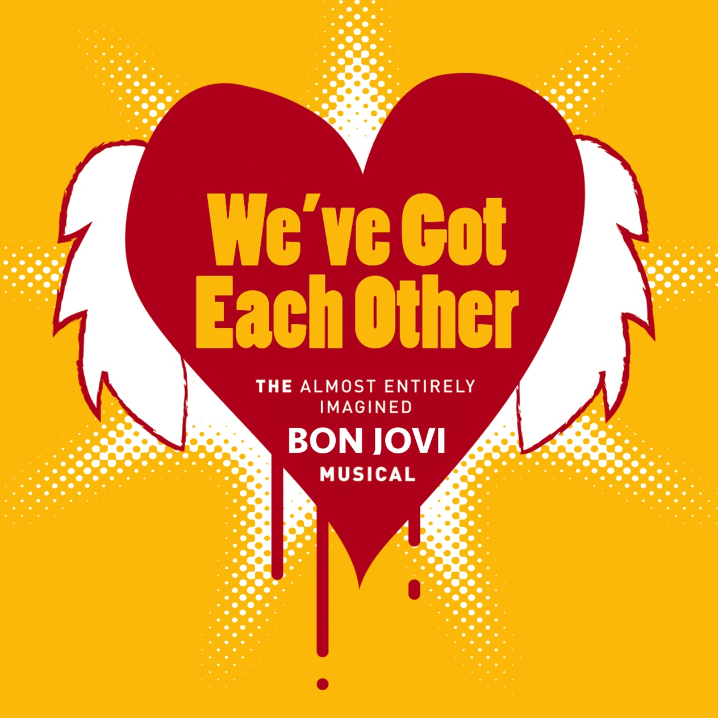

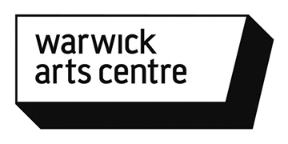

CONTENTS

2. Contents
3. Brochure Copy
4. About: The Show
5. About: Paul O’Donnell
6. Creative Team
8. Target Audiences & Key Messages
9. Tour Dates
11. Audience Feedback
12. Production Images
13. Technical Details
14. Contact

BROCHURE COPY

WE’VE GOT EACH OTHER
by Paul O’Donnell

Commissioned by China Plate, mac birmingham, Warwick Arts Centre and In Good Company.
Supported by Camden Peoples Theatre and Arts Council England.

The almost entirely imagined Bon Jovi Musical.

With the modern jukebox musical traditionally comes a multi-talented cast, a live band (or orchestra if you are lucky), opulent sets and decadent costumes, extravagant dance routines, dramatic key changes and the odd hydraulic lift or two. We’ve Got Each Other has none of these things (they cost a lot of money), but Paul still tries to create this all singing, all dancing spectacle using the powers of your imaginations.
Through entertaining descriptions of the show as it unfolds, and a hundred plus lighting cues, Paul invites the audience to ‘fill in the gaps’ and imagine the breath-taking tragic love story of Tommy and Gina.
[Winner of BE Festivals Early Ideas Award 2017]
[Winner of BE Festivals Audience Prize 2018]
[Winner of FITT Festival Tarragona’s Audience Prize 2018]
[Winner of FITT Festival Tarragona’s Best Performer Prize 2018]

Twitter Hashtag: #WeveGotEachOther
Trailer: https://www.youtube.com/watch?v=4Yg1TL004ac
(For video mp4 please email pajod@hotmail.co.uk)

Running Time: approx. 1 hour
Age Range: Recommended 12+ (mild language may be used)

Brochure/Lead Image: For High Resolution images please contact pajod@hotmail.co.uk
ABOUT: THE SHOW

With the modern jukebox musical traditionally comes a multi-talented cast, a live band (or orchestra if you are lucky), opulent sets and decadent costumes, extravagant dance routines, dramatic key changes and the odd hydraulic lift or two. We’ve Got Each Other has none of these things (they cost a lot of money), but Paul still tries to create this all singing, all dancing spectacle using the powers of the audiences imagination.

We’ve Got Each Other is a satirical look into the musical theatre genre. It explores the creative power our imagination holds, as well as the partnership / community that is built between audience and artist. Neither can exist without the other.

We’ve Got Each Other has been developed through a First Bite Commission from China Plate, Warwick Arts Centre, mac Birmingham and In Good Company. It is entering a Research & Development phase aiming to be complete by October 2017.

THE SHOW

We’ve Got Each Other is a Bon Jovi, jukebox musical that is almost entirely imagined by the audience. A vulnerable ‘Paul’ begins by admitting he is unable to resource a full production with cast of 35 and 7 piece band. We are left with an empty performance space and a solo performer. Utilising only lighting and a series of cover versions of ‘Livin’ On A Prayer’ Paul describes the musical he would have made and attempts to conjure set, costumes, cast, extravagant dance routines and a hydraulic lift in the spectators imagination.
The musical tells the story of Tommy and Gina, two principle characters taken from Bon Jovi’s song Livin’ On A Prayer. It follows the story of their forbidden love for one another, Tommy being an American docker and Gina being a Spanish waitress. With music by Jon Bon Jovi and choreography by Bruno Tonioli it is sure to delight and entertain.
ABOUT: PAUL O’DONNELL

Paul O’Donnell is a theatre maker and producer, based in Coventry. He is Associate Artist at Birmingham Repertory Theatre and Theatre Absolute. Pauls work aims to expose the ‘ordinary’ in a ‘spectacular’ fashion.

His previous work includes an all singing all dancing harem of Paul’s exploring our human need to feel like a ‘something’ (Nothing!), one very 'real' cowboy in a very 'real' saloon (So Far West), and a mime artist who is trying to break free of his glass box (One Thing On His Mime).

In October 2016 Arcola Theatre (London) commissioned Paul to devise a ‘West End’ musical in collaboration with their Over 50’s community cast inspired by an early scratch of We’ve Got Each Other. Beautiful: Not The Carole King Musical premiered in January 2017 and was very positively received. It returned for an extra fundraising event in April 2017 supporting this community group’s expansion.

In 2018, Paul was awarded BE Festival’s Audience Prize for We’ve Got Each Other, voted for by the audience themselves across the entire festival. Following this he toured the show to FITT Festival in Tarragona, Spain. Here he was again awarded an Audience Prize voted for by the audience, as well as the Best Performer award, selected by an industry panel.

Paul also produces Shoot Festival in Coventry, which is an annual platform for CV based emerging artists. It is funded by Arts Council England, Coventry City Council and Belgrade Theatre and supported by Shop Front Theatre, Tin Music and Arts, City Arcadia and Birmingham Rep. 2017’s event supported eighteen artists, created five new commissions and offered workshops, talks and family activities.

Paul O’Donnell: www.podonnell2.co.uk
Shoot Festival: www.coventryshootfestival.com

CREATIVE TEAM

NICK WALKER
Dramaturg

Nick is a writer and director. He has worked with some of the country’s leading new work theatre companies including Action Hero, Stan’s Cafe, Insomniac, Debbie Isitt’s Snarling Beasties, NoFit State, Bootworks, and Kiln.

Recent theatre work includes new writing commissions for the Oxford Playhouse, Birmingham Rep, and the Belgrade Theatre (including the popular football hit We Love You City). His plays and short stories are regularly featured on BBC Radio 4, including 3 series of The First King of Mars (starring Peter Capaldi), 3 series of The Bigger Issues, and 3 series of his Scandinavian thriller, Annika Stranded, starring Nicola Walker.

He is director of independent radio company Top Dog whose series The Music Teacher was nominated for a Writers Guild of Great Britain award. He is the author of two critically acclaimed novels Blackbox and Helloland and was co-founder of Talking Birds, a Coventry-based theatre company whose work has been presented across the UK, Europe, and the USA. Nick is currently the Director of The Core at Corby Cube, which is a performing arts centre in the East Midlands.

ARNIM FRIESS
Lighting Designer
Arnim specialises in designing dynamic performance environments, blending lighting, video, photography and motion graphics. His lighting and projection designs have been seen not only in theatres around the world, but also in a zoo, a monastery, an abandoned pub and deep down in a cave.
Recent designs include ‘Alice in Wonderland’ Polka Theatre, ‘Ghosts in the Wall’ for the RSC, ‘Piaf’ and ‘Gypsy’ at The Curve Leicester, Leviathan (Matadero Madrid), Grandpa in my pocket (Nottingham Playhouse), ‘Wander’ at the Jockey Club Theatre Hong Kong, the National Holocaust Memorial Day, ‘The Rememberers’ for Birmingham Rep, a roof of light for Coventry Cathedral’s Blitz commemoration, 'Lucky Seven' for Hampstead Theatre, ‘Looking for JJ’ for Pilot Theatre at the Unicorn, ‘One Night in November’ for the Belgrade Theatre Coventry, 'The Suicide' and 'An Inspector calls' at Theatr Clwyd, 'The White Album' at the Nottingham Playhouse.
www.pixelbox.ltd.uk

TARGET AUDIENCES AND KEY MESSAGES / BENEFITS

- Studio Audiences – A funny and ironic performance that intelligently plays with, and deconstructs, the musical theatre genre.
- A solo performance by an up and coming artist supported by the renowned team at China Plate, Nick Walker (Dramaturg) and Arnim Friess (Lighting Designer).

- Musical Theatre Audiences – Audiences who have attended previous musical theatre shows. Local musical theatre groups / university societies.
- A high quality show that creates the feeling of a full scale musical in small-scale studios drawing upon the audience’s imagination.
- Marketing materials will be designed as a parody of West-End musical marketing e.g. Musical trailers, flyers.

- Comedy/Stand-up Audiences – We’ve Got Each Other employs presentational forms that resonate with stand up audiences. Use of microphone, direct address and countless punch lines.

- Tribute Act Audiences & Bon Jovi Fans (1980’s rock more widely) – The show is centred around the idea of a Bon Jovi musical and features numerous cover versions of this song.

- LGBT Audiences – a high camp show centred around musicals, from an LGBT artist. There will be dance routines, there will be a sing along, and there will be a Glitter Ball.

- Audiences for other work that plays with genre/form – e.g. Action Hero, The Pretend Men, Sh!t Theatre.

- Academic Audiences – A chance to see theatre that is routed in audience imagination, and work that effectively utilises its own limits and restrictions as a creative tool.
PREVIOUS TOUR DATES

WARWICK ARTS CENTRE (BITE SIZE FESTIVAL), COVENTRY
Sat 7th October (2017)
024 7652 4524
www.warwickartscentre.co.uk

AXIS ARTS CENTRE, CREWE
Tues 24th October (2017)
0843 2080 500
www.axisartscentre.org.uk

CONTACT THEATRE (FLYING SOLO FESTIVAL), MANCHESTER
Thurs 2nd November (2017)
0161 274 0600
www.contactmcr.com

MAC, BIRMINGHAM
Sat 2nd December (2017)
0121 446 3232
www.macbirmingham.co.uk

CAMDEN PEOPLES THEATRE
Thurs 14th, Fri 15th, Sat 16th December (2017)
020 7419 4841
www.cptheatre.co.uk

LINCOLN DRILL HALL
Thurs 8th February (2018)
01522 873894
www.lincolndrillhall.com

DERBY THEATRE, DERBY
Fri 9th February (2018)
01332 59 39 39
www.derbytheatre.co.uk

[CONTINUED]
ATTENBOROUGH ARTS CENTRE (LEICESTER COMEDY FESTIVAL) LEICESTER
Sat 17th February (2018)
0116 252 2455
www2.le.ac.uk/hosted/attenborougharts

ACT FESTIVAL, BILBAO (Spain)
Thu 31st June (2018)
http://bai-bai.net/act/?p=3155

PULSE FESTIVAL, NEW WOLSEY THEATRE, IPSWICH
Sat 9th June (2018)
01473 295900
https://www.wolseytheatre.co.uk/shows/pulse18-weve-got-each-other/

BE FESTIVAL, BIRMINGHAM REPERTORY THEATRE
Fri 6th July (2018)
0121 236 4455
https://www.birmingham-rep.co.uk/whats-on/be-festival-friday-main-programme-2018.html

FITT FESTIVAL TARRAGONA (Spain)
Wed 18th July (2018)
977 222 014
http://www.fitt.cat/weve-got-each-other/#

UPCOMING TOUR DATES

To make an enquiry about booking the show, please contact Paul directly: pajod@hotmail.co.uk

EDINBURGH FRINGE FESTIVAL, PLEASANCE JACK-DOME
Wed 1st August – Mon 27th August (2018)
020 7609 1800
https://www.pleasance.co.uk/event/weve-got-each-other#overview

AUDIENCE FEEDBACK

Paul Warwick (Director of China Plate)
“A fascinating exercise of the imagination”

Tamsin Drury (Director of hAb & Word of Warning)
“We’ve Got Each Other shows great development and enormous promise. It was my highlight of Emergency 2016 - my only regret is not having programmed it as the finale!”

FIRST BITE FESTIVAL [Audience feedback forms]

“Hugely enjoyable and entertaining. I thought you captured the conventions of musical theatre with real wit and comic value.”
“INCREDIBLE”
“So brilliant! Works very cleverly on our perceptions of theatre.”
“Genius! Desperate to see full musical!”

SOCIAL MEDIA
@LianWilkinson: @podonnell2’s #wevegoteachother elicited the reaction of “I’ve really got to see more theatre” from my plus 1, which is much better feedback than anything I can add #TheatreRecommendation #BonJoviMusical #TripleTheatre
@ClaireKathF: We’ve Got Each Other is one of the best musicals I’ve never seen. Fantastic production at @axisartscentre last night #WeveGotEachOtherPaul
@Jenny_Acts: Last night I saw #WeveGotEachOther by @podonnell2 & it’s still making me laugh now. I’ve never seen anything like it and I want more! If you love @BonJovi or #Theatre or just want to laugh till your face hurts you must go. #GiveItAShot
@TerriTexmabob: @podonnell2 made me laugh so hard that I left the theatre with a paella induced six pack #Wevegoteachother @ContactMcr
PRODUCTION IMAGES
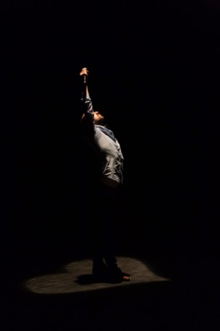
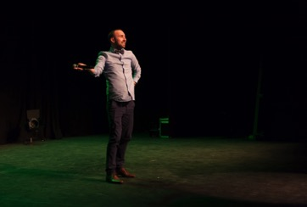
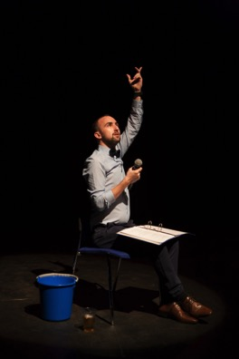

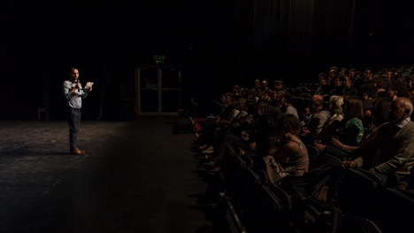
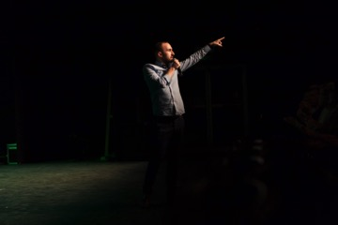

Photo Credit:
Simon K Allen TECHNICAL DETAILS

RUNNING TIME
60 minutes – no interval

CAST AND CREW
1 performer, 1 technical operator/stage manager

CONFIGURATION
End on – Preferably raked seating

STAGING
No touring set required
1 chair (to be provided by venue)

LIGHTING
(To be provided by venue)
Use of the venues dimmers, lanterns and lighting board is required
Five spotlights (1 centre stage, 1 centre right, 1 centre left, 1 tight focus down right, 1 centre stage with heart shape gobo – gobo provided by company)
Glitter Ball
Lighting will be programmed through Qlab

AUDIO
1 wireless handheld Microphone (Preferably provided by venue, but Paul is also able to bring if needed)
MP3 Tracks – to be played through Qlab

OTHER
Smoke machine (Preferably with loud smoke output)

CONTACT

PAUL O’DONNELL (Performer / Producer)
Email: pajod@hotmail.co.uk
Mob: 07964631147

Web: www.podonnell2.co.uk

Twitter: @podonnell2
Facebook: @podonnell6

